TMGT 4040 Online Assignment: Comparing and Contrasting Sustainable Tourism Models and Actions

*February 5, 2020*

**This “virtual” assignment is to replace the regularly scheduled**

**TMGT 4040 class on Friday, February 5.**

**ASSIGNMENT DESCRIPTION**

For this assignment, in a group of two (2), or by yourself, you are to do the following:

1. **Review the following sustainable tourism models:**
2. David Weaver’s “Deliberate Alternative Tourism” Model (Figure 1)
3. C. Michael Hall et al’s Sustainable Tourism VENN Diagram (Figure 2).
4. Regenerative Travel (<https://www.regenerativetravel.com/the-regenerative-shift/>) – spend some time looking at the background videos and summaries of Regenerative Travel to become familiarized with the concept.

These are three prominent models associated with current understandings of “Sustainable Tourism.”

1. **For each model, identify the following:**

In a short (approx. 2 page) document, describe the essential elements of each type of “sustainable tourism” (or responsible tourism, ethical tourism, “good” tourism…). What aspect of sustainable tourism are they most focused on: i) Destination planning; ii) Business planning; or iii) Consumer behaviours. What are the overall objectives associated with each type of tourism? Are they more or less addressing the same aspects of “sustainable / responsible / ethical / good” tourism, or do they have some fundamental differences/

The assignment is due at 5:00 PM, Friday, February 12, 2021 via Moodle (submission folder at top of class page). This assignment is part of course participation, not graded independently (but still do a good job of it!) 😊

**Figure 1: David Weaver’s “Deliberate Alternative Tourism” Model**

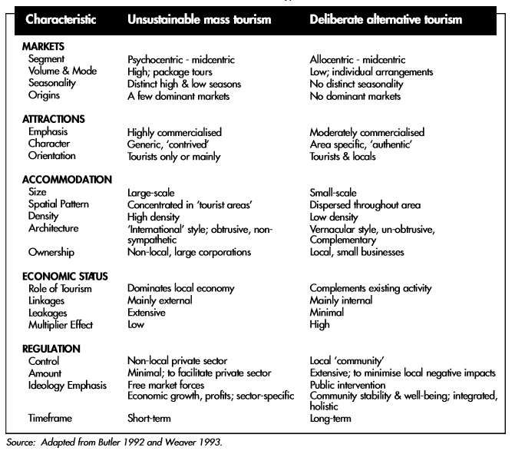

**Figure 2: C. Michael Hall et al’s Sustainable Tourism VENN Diagram**

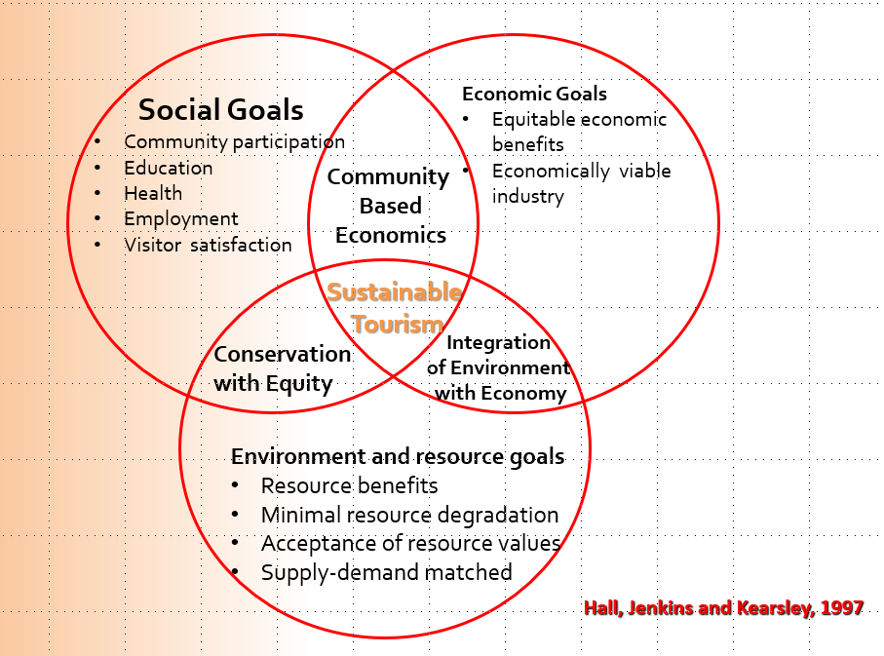

**Figure 3: Sustainable Tourism Destination Toolkit (Larose, 2019)**

